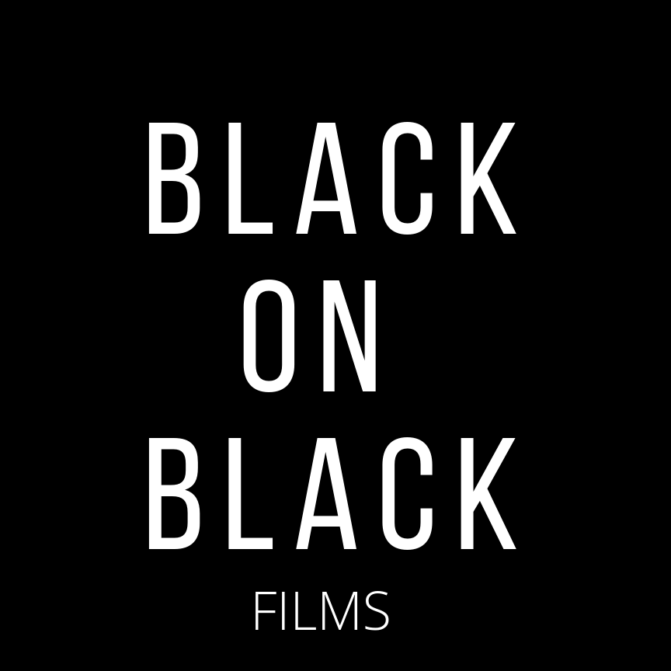

PROJECT « JE ME VOIS À L’ÉCRAN »

Screenwriting residency for emerging film artists from
Afro-descendant communities in Montreal

Application Form

Please consult the document "Presentation of the residency program“ to know:

- The aid granted
- The application deadline
- Objectives and description of the program
- The general conditions of eligibility and inadmissibility
- The nature of the support
- The evaluation of applications
- The terms of payment of the grant
- The obligations of the selected artist
- How to apply
- Program contact information.

Also follow the following guidelines:

- Please send your application to the email address provided in one mailing.

- Documents must be submitted in PDF format.

- Documents to be sent:

□ The form duly completed and signed.
□ A letter of intention explaining why you want to participate in this program.
□ Excerpt from an earlier script written in French or English, 4 pages max (PDF format)
□ Or any cinematic creation: fiction, documentary, music videos etc… (video link)
□ A synopsis of the short fiction film project you want to write; 1 page max (PDF format)
□ Your CV.

BLACK on BLACK FILMS
Screenwriting Residency « Je me vois à l’écran »
APPLICATION FORM
Identification of the artist
1. Name of the artist

Last Name First name
2. Mailing address

No Street City Postal Code

Borough :
3. Other details of the artist
Home Phone : - -
Cell Phone : - -
Email :
Web Site (Optional) :
Additional Information
4. Check the appropriate boxes, if applicable
Gender
Female Male Other
Afro-descendant

Status
Candian Citizen Permanent Resident Other (Refugee, PVT, etc.) Specify
Born in Canada Born outside of Canada, indicate country of birth :

If you were born outside Canada, how many years have you lived there?

I certify that the information provided in this application for creative support is accurate and complete.

Signed in Montreal on: - -
Mo - Day - Year

_______________________________ ____________________________________
Signature of Artist Name in print

Your application must be sent in one single package to:

Black on Black Films
jmvae@blackonblackfilms.org

Deadline: November 22 2020 – 11h59 PM

